**9. Programming on class**

**9.1 Aim**

Write a program to create a Bank account and Rectangular using class object with initial parameter for the program statement given below.

**9.2 Software Used**

1. Anaconda Navigator
2. Jupyter Notebook
   1. **Pre Lab Questions**
3. What is a class? How to create a class
4. Explain the following term “self” and __init__ in class

**9.4 (a) Program statement 1**

1. Create a Python class called **BankAccount** which represents a bank account, having as attributes: **accountNumber** (numeric type), **name** (name of the account owner as string type), balance.
2. Create a **constructor** with parameters: **accountNumber, name, balance**.
3. Create a **Deposit()** method which manages the deposit actions.
4. Create a **Withdrawal() method**  which manages withdrawals actions.
5. Create an **bankFees()**method to apply the bank fees with a percentage of 5% of the balance account.
6. Create a **display()**method to display account details.
7. Give the complete code for the  **BankAccount class**.

**9.5 (a) Program 1 Code:**

class BankAccount:

# create the constructor with parameters: accountNumber, name and balance

# create Deposit() method

# create Withdrawal method

# create bankFees() method

# create display() method

# Testing the code :

# Creating Withdrawal Test

# Create deposit test

# Display account informations

**Output Response:**

Account Number :

Account Name :

Account Balance :

**Code:**

class BankAccount:

def __init__(self, accountNumber, name):

self.accountNumber = accountNumber;

self.name = name;

self.balance = 0;

def bankFees(self):

self.balance = self.balance - (5/100)*self.balance;

print("5% bank fees applied for withdrawal");

return;

def deposit(self, amount):

self.balance = self.balance + amount;

print("Current balance after deposit:", self.balance)

return self.balance;

def withdrawal(self, amount):

self.balance = self.balance - amount;

self.bankFees();

print("Current balance after withdrawal:", self.balance)

return self.balance;

def details(self):

print("Account No.:", self.accountNumber);

print("Name:", self.name);

print("Current Balance:", self.balance);

return;

**Observation:**

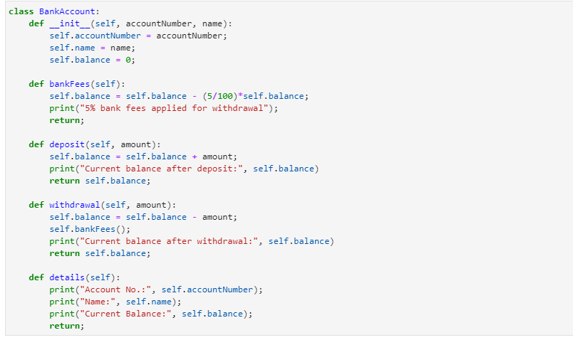

**Output:**

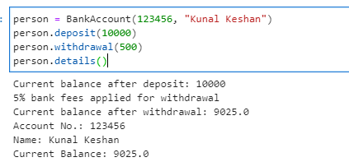

**9.4(b) Program statement 2**

1. Write a **Rectangle class** in Python language, allowing you to build a rectangle with **length** and **width** attributes.
2. Create a **Perimeter()** method to calculate the perimeter of the rectangle and a **Area()**method to calculate the area of ​​the rectangle.
3. Create a method **display()** that display the length, width, perimeter and area of an object created using an instantiation on rectangle class.
4. Create a **Parallelepipede** child class **inheriting** from the **Rectangle class** and with a **height** attribute and another **Volume()** method to calculate the volume of the **Parallelepiped.**

**9.5(b) Program 2 Code**

class Rectangle:

# define constructor with attributes: length and width

# Create Perimeter method

# Create area method

# create display method

# define Volume method

**output response:**

The length of rectangle is: 7

The width of rectangle is: 5

The perimeter of rectangle is: 24

The area of rectangle is: 35

----------------------------------

the volume of myParallelepipede is: 70

**Code:**

class Rectangle:

def __init__(self, length, width):

self.length = length;

self.width = width;

def perimeter(self):

return 2*(self.length+self.length)

def area(self):

return self.length*self.width;

def details(self):

self.perimeter();

self.area();

print("Length:", self.length);

print("Width:", self.width);

print("Perimeter:", self.perimeter());

print("Area:", self.area());

class Parallelepipede(Rectangle):

def __init__(self, length, width, height):

super().__init__(length, width)

self.height = height;

def volume(self):

volume = self.length*self.height*self.width;

print("Volume is:", volume)

return volume;

twod = Rectangle(6,9);

twod.perimeter();

twod.area();

twod.details();

threed = Parallelepipede(6,9,9)

threed.volume()

**Observation:**

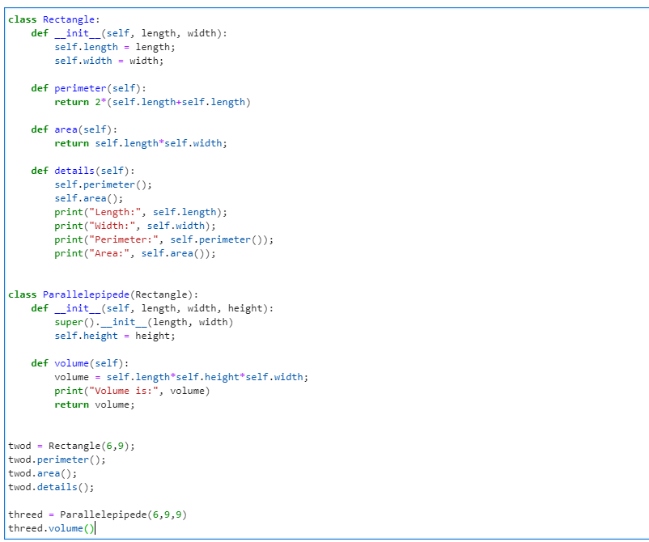

**Output:**

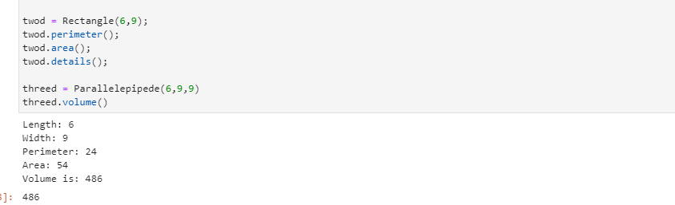

**9.6 Post Lab Questions**

1. Create a Cricle class and intialize it with radius. Make two methods getArea and get Circumference inside this class.
2. Create a Temprature class. Make two methods :  
   1. convertFahrenheit - It will take celsius and will print it into Fahrenheit.  
   2. convertCelsius - It will take Fahrenheit and will convert it into Celsius.

**9.7 Result**

Write a program to create a Bank account and Rectangular using class object with initial parameter for the program statement